**1DAILY ONLINE ACTIVITIES SUMMARY**

|  |  |  |  |  |  |  |  |  |
| --- | --- | --- | --- | --- | --- | --- | --- | --- |
| **Date:** | **18-7-2020** | | | | | **Name:** | **poojashree** | |
| **Sem & Sec** | **8th sem A sec** | | | | | **USN:** | **4al16cs065** | |
| **Online Test Summary** | | | | | | | | |
| **Subject** | |  | | | | | | |
| **Max. Marks** | |  | | **Score** | | |  | |
| **Certification Course Summary** | | | | | | | | |
| **Course** | **Introduction to cyber security** | | | | | | | |
| **Certificate Provider** | | | **Great learning academy** | | **Duration** | | | **5.5hr** |
| **Coding Challenges** | | | | | | | | |
| **Problem Statement:**  **Program to eliminate first character of each word of a string in C** | | | | | | | | |
| **Status:completed** | | | | | | | | |
| **Uploaded the report in Github** | | | | | **yes** | | | |
| **If yes Repository name** | | | | | **Poojashree** | | | |
| **Uploaded the report in slack** | | | | | **yes** | | | |

**Online test**

**----------no marks -----------**

**Certification course**

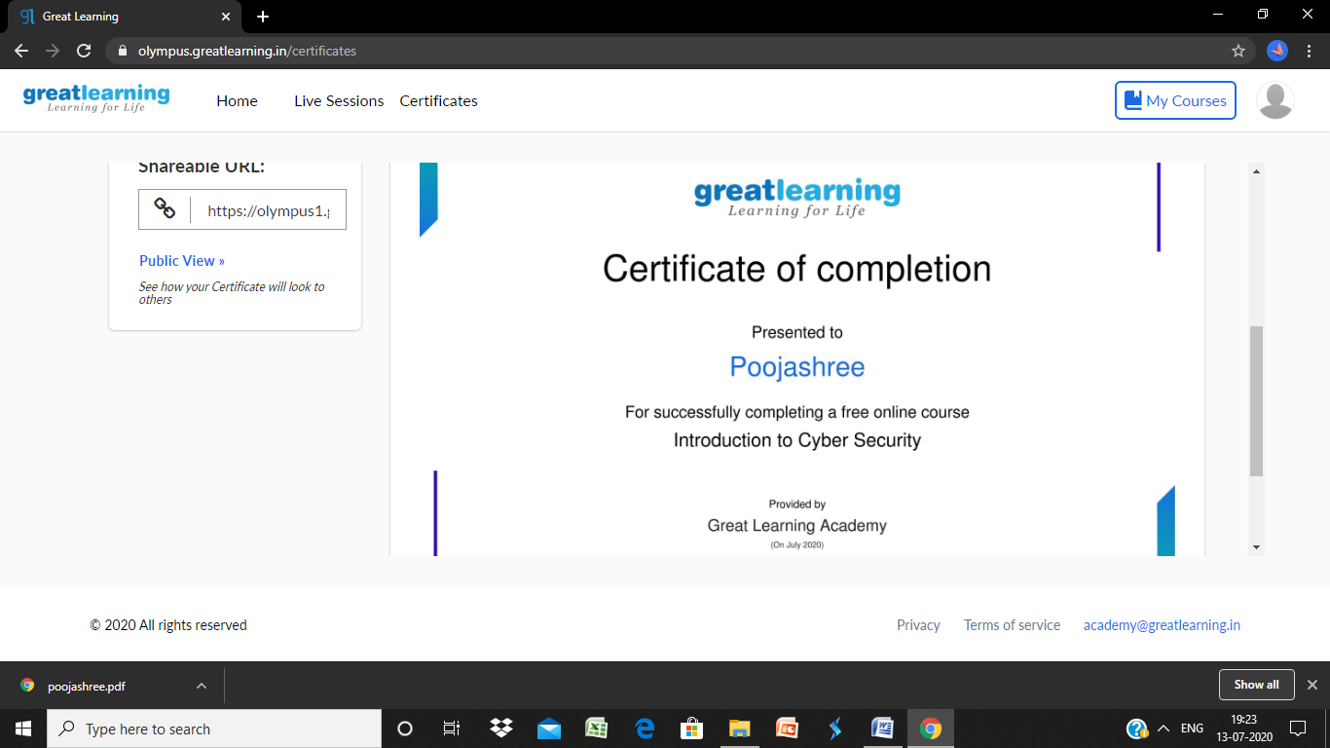

**Coding**

**Program 1**

**#include <stdio.h>**

**#define MAX 100**

**int main()**

**{**

**char text[MAX]={0};**

**int loop,j;**

**printf("Please input string: ");**

**scanf("%[^\n]s",text); //read string with spaces**

**printf("Input string is...\n");**

**printf("%s\n",text);**

**for(loop=0; text[loop]!='\0'; loop++)**

**{**

**if(loop==0 || (text[loop]==' ' && text[loop+1]!=' '))**

**{**

**//shift next characters to the left**

**for(j=((loop==0)?loop:loop+1); text[j]!='\0'; j++)**

**text[j]=text[j+1];**

**}**

**}**

**printf("Value of \'text\' after eliminating first character of each word...\n");**

**printf("%s\n",text);**

**return 0;**

**}**